**-E TOOL GUIDANCE**

**STATION 1: Attach PSU to Bottom Plate**

1. Set Bottom Plate into Wood Block Slot
2. **CONFIRM BLUE TAPE IS UP and towards Edge of Table**
3. Set PSU On Plate with **3 Screw Side** (**AC Power Side) TOWARDS BLUE TAPE (See Picture)**
4. Put screw in all 4 holes with Screw Head on the Power Supply Side (use screw drive to guide them in)
5. Drop Nut into Nut Driver Tool - **NYLON SIDE FIRST**
6. Tighten Nut onto the screws FARTHEST FROM YOU first
7. Repeat for Each Screw
8. Confirm Screw is sticking out over the edge of the nut
9. Place In Staging Area to the Right

NOTES:

* Only Grab 1x nut at a time
* Do Not Set Nuts or Screws on the table ONLY IN BINS
* Keep firm Pressure down on the screw driver
* Do not OVER tighten (will strip the screw head)
* KEEP TOOLS AT STATION IN TOOL SPOT

Bottom Plate IN Wood Block Slot

PSU Sitting on top, BLUE TAPE UP

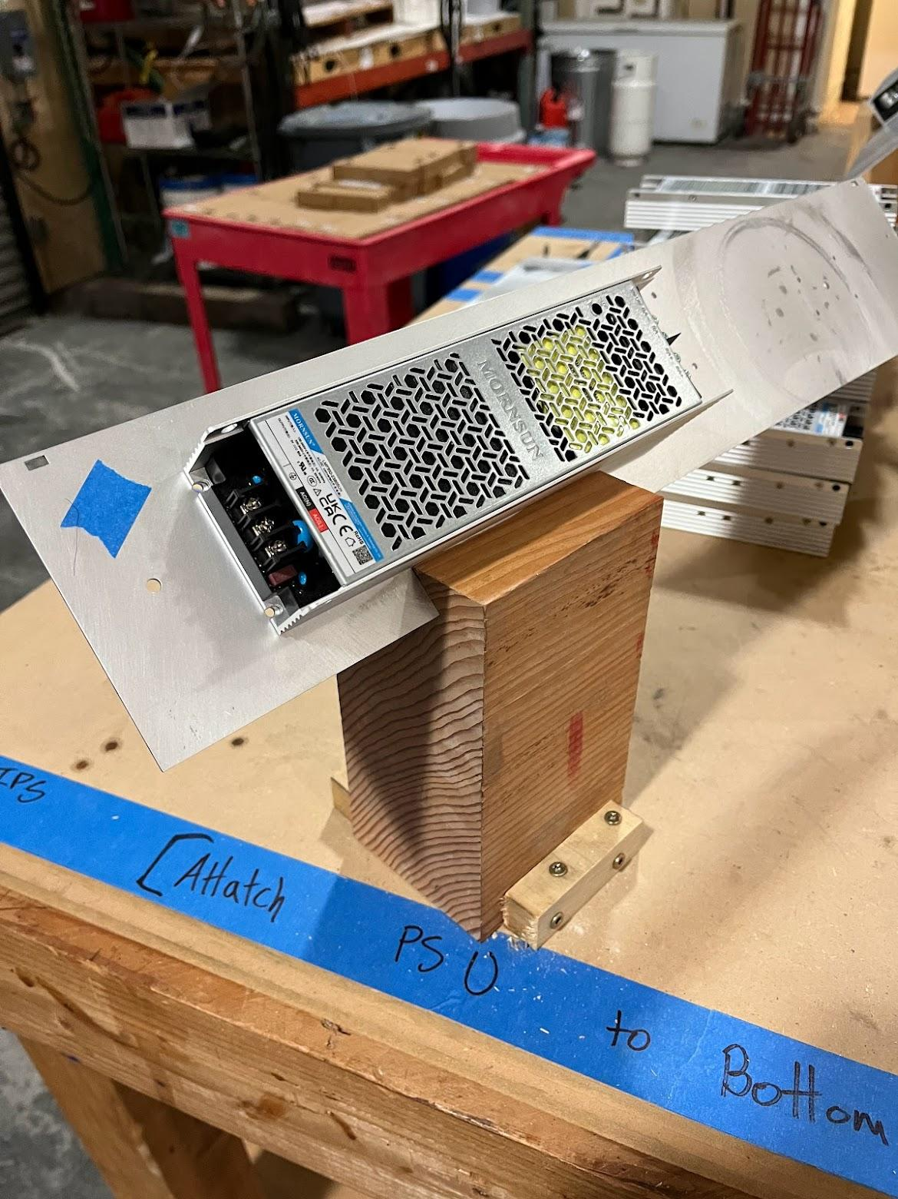

CONFIRM BOLT IS STICKING ABOVE NUT: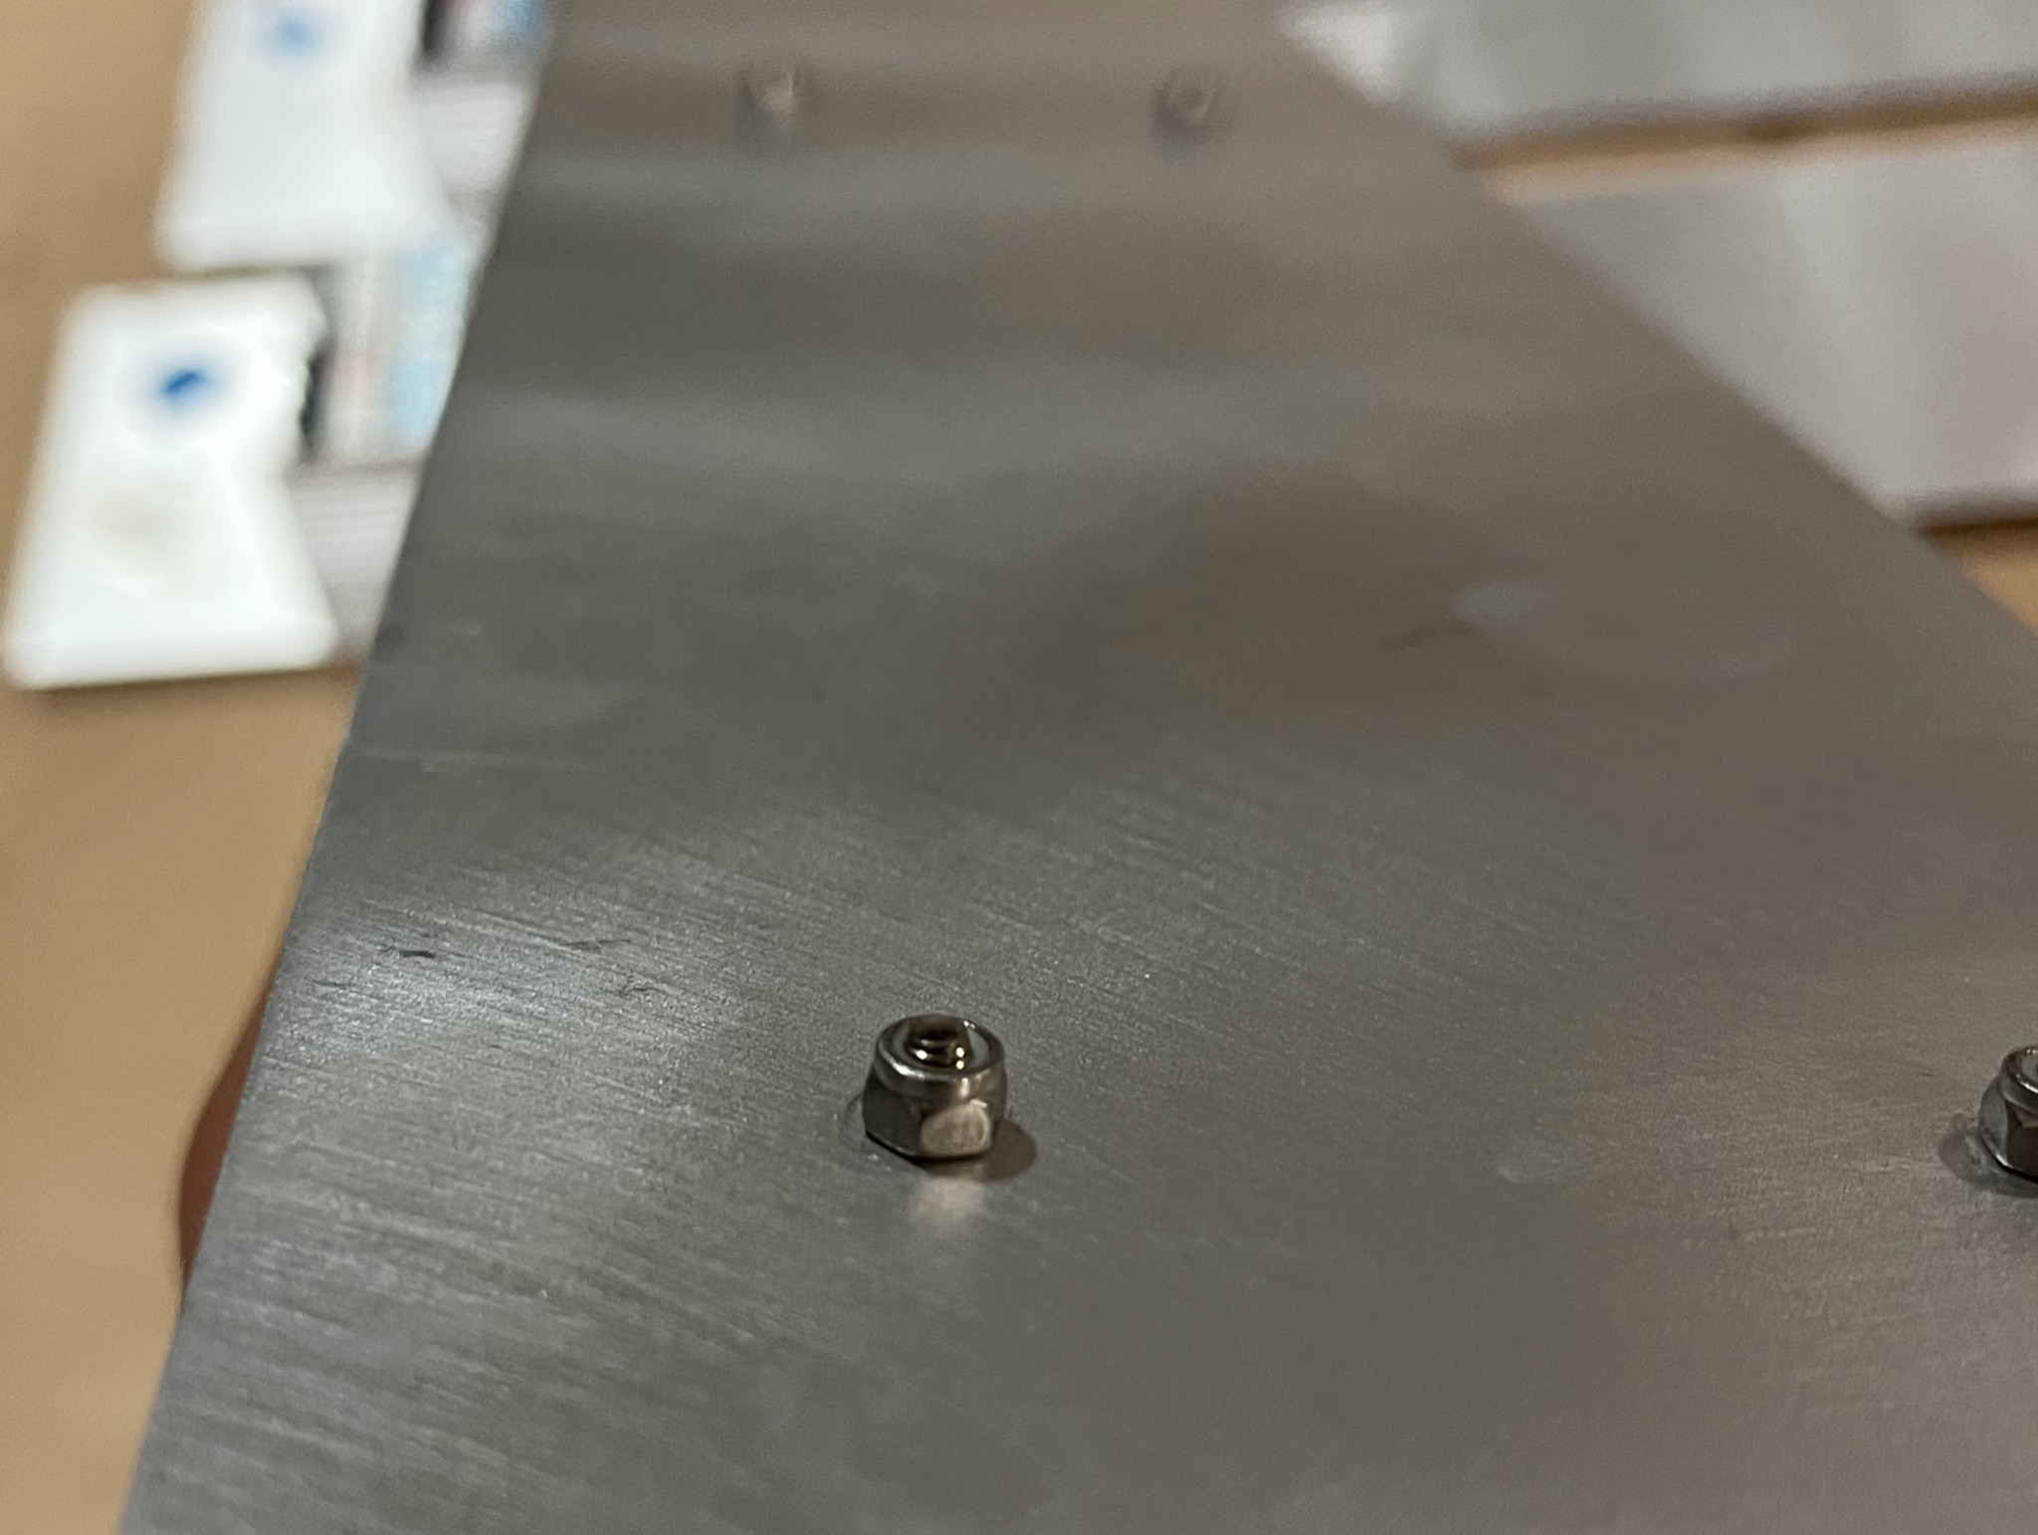

AC SIDE AND LABEL TOWARDS BLUE TAPE:

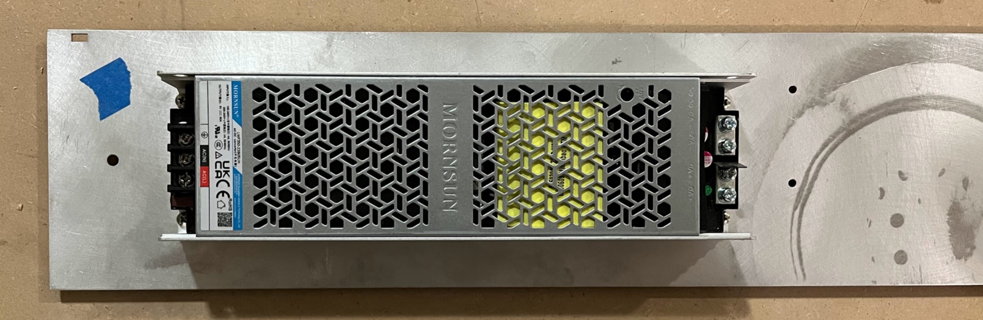

NON NYLON SIDE NYLON SIDE 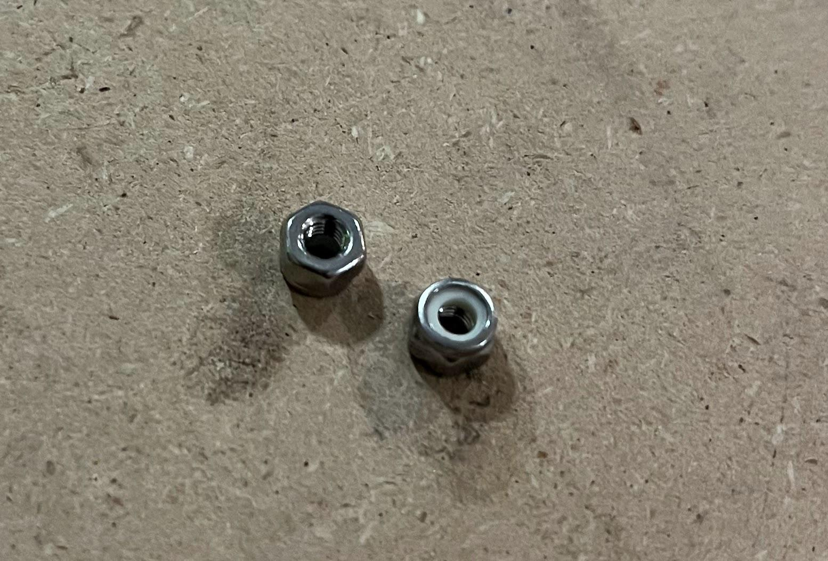

PLACE NYLON SIDE INTO BIT DRIVER FIRST

STATION 2: ADD CANOPY STANDOFFS

1. (Quality Control from station 1): Confirm PSU Bolts are stick out out of Nut from below plate (if not send back to station 1)
2. Insert PSU+Bottom Plate in between wood blocks on table (see pic)
3. Grab one **Screw** in one hand and one **StandOff Nut** in the other
4. Insert the screw from the bottom Side in holes highlighted below
5. Start the threads by hand loosely (don’t tighten)
6. Do all 4 Screws
7. Tighten: Use Screwdriver and Nut Driver to tighten firmly

Notes:

* You may find a standoff nut that is too small in your bin, if so, bring it to station 3 (angio standoff station)

Holes Highlighted in Yellow:

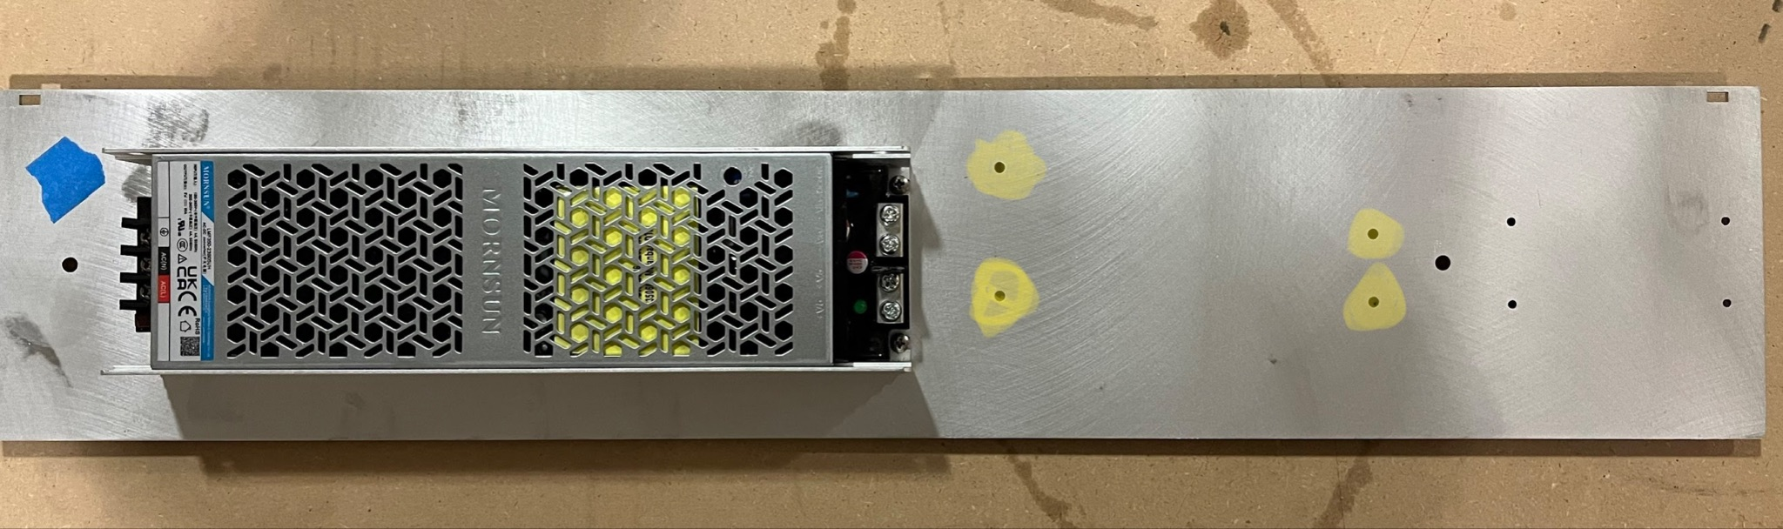

Standoffs on PSU Side of Bottom Plate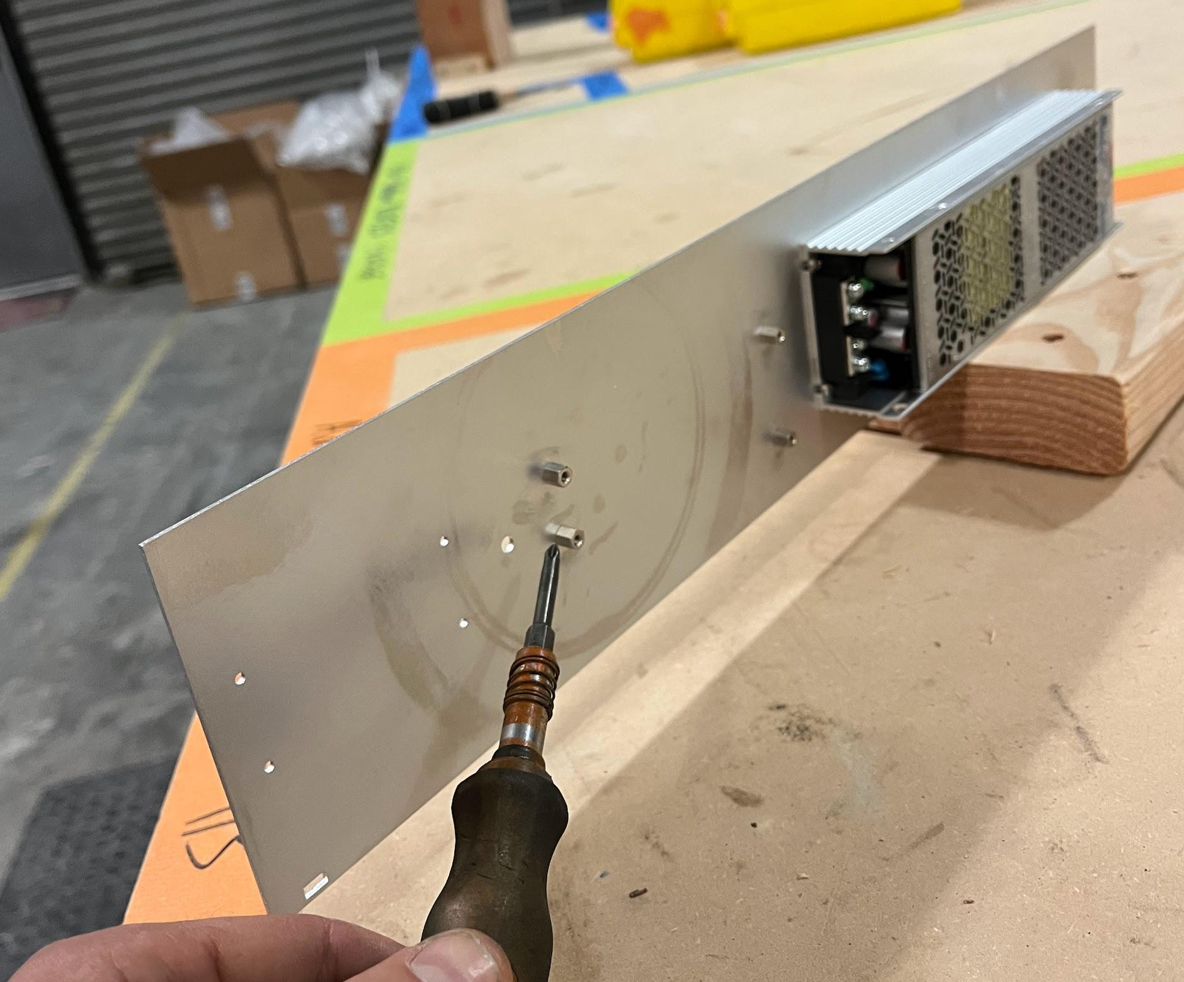

STATION 3: ADD ANGIO STANDOFFS

1. (Quality Control from station 2): Wiggle Standoffs with hand and confirm they are tight and do not spin (if not send back to station 2)
2. Insert PSU+Bottom Plate in between wood blocks on table (see pic)
3. Grab one **Screw** in one hand and one **StandOff Nut** in the other
4. Insert the screw from the bottom Side in holes highlighted below
5. Start the threads by hand loosely (don’t tighten)
6. Do all 4 Screws
7. Tighten: Use Screwdriver and Nut Driver to tighten firmly

Notes:

* You may find a standoff nut that is too small in your bin, if so, bring it to station 3 (angio standoff station)

Holes Highlighted in Yellow

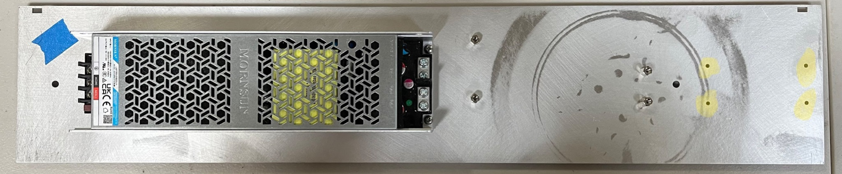

Standoffs on PSU side of Bottom Plate

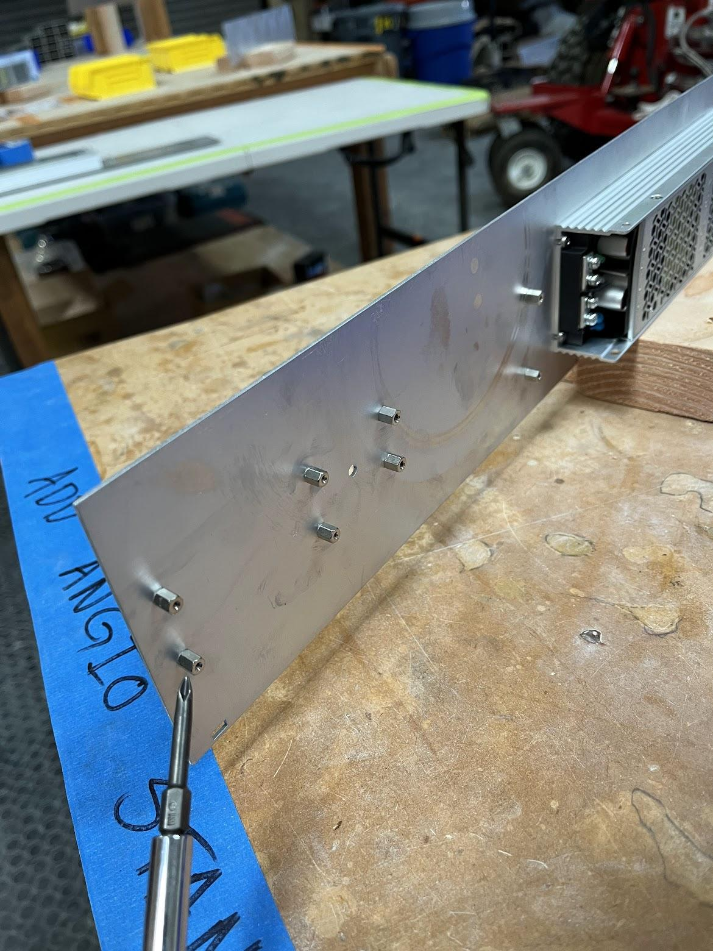

STATION 4: ADD CANOPY POWERBOARD AND FUSES

1. Set a Bottom Plate + PSU assembly at station
2. (Quality Control Station 2+3): Confirm All standoffs feel very tight and dont spin
3. Set a Canopy Powerboard on top of its Standoffs in Orientation Pictured Below
4. Put a screw on the end of your screwdriver (the driver will hold the screw a bit)
5. Guide the screw into the standoff and start threading it but do not tighten all the way
6. Insert the remaining screws in each of the remaining 3 positions and tighten all 4 firmly.
7. Insert 4x Fuses in the Fuse Holders Centered, (They are hard to insert)
8. Confirm Fuses are inserted properly (Not Diagonally, but centered in the metal clips)

CANOPY POWER BOARD ORIENTATION AND STANDOFFS HIGHLIGHTED

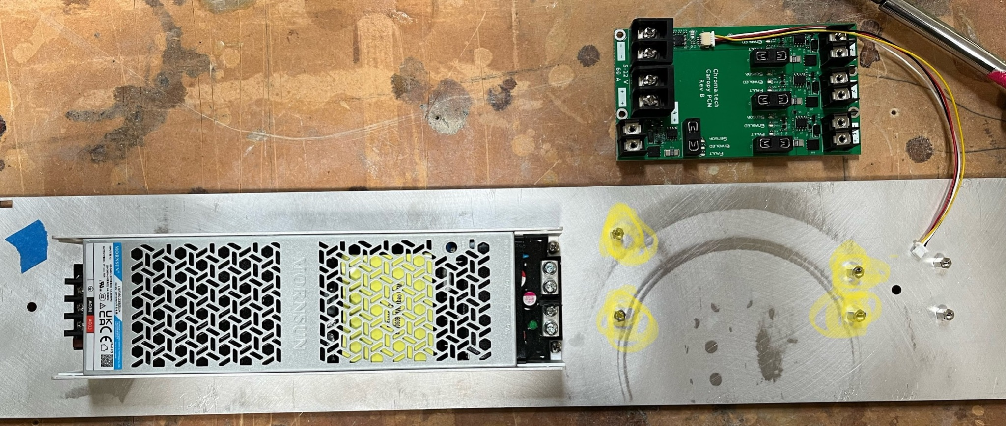

With Fuses Inserted:

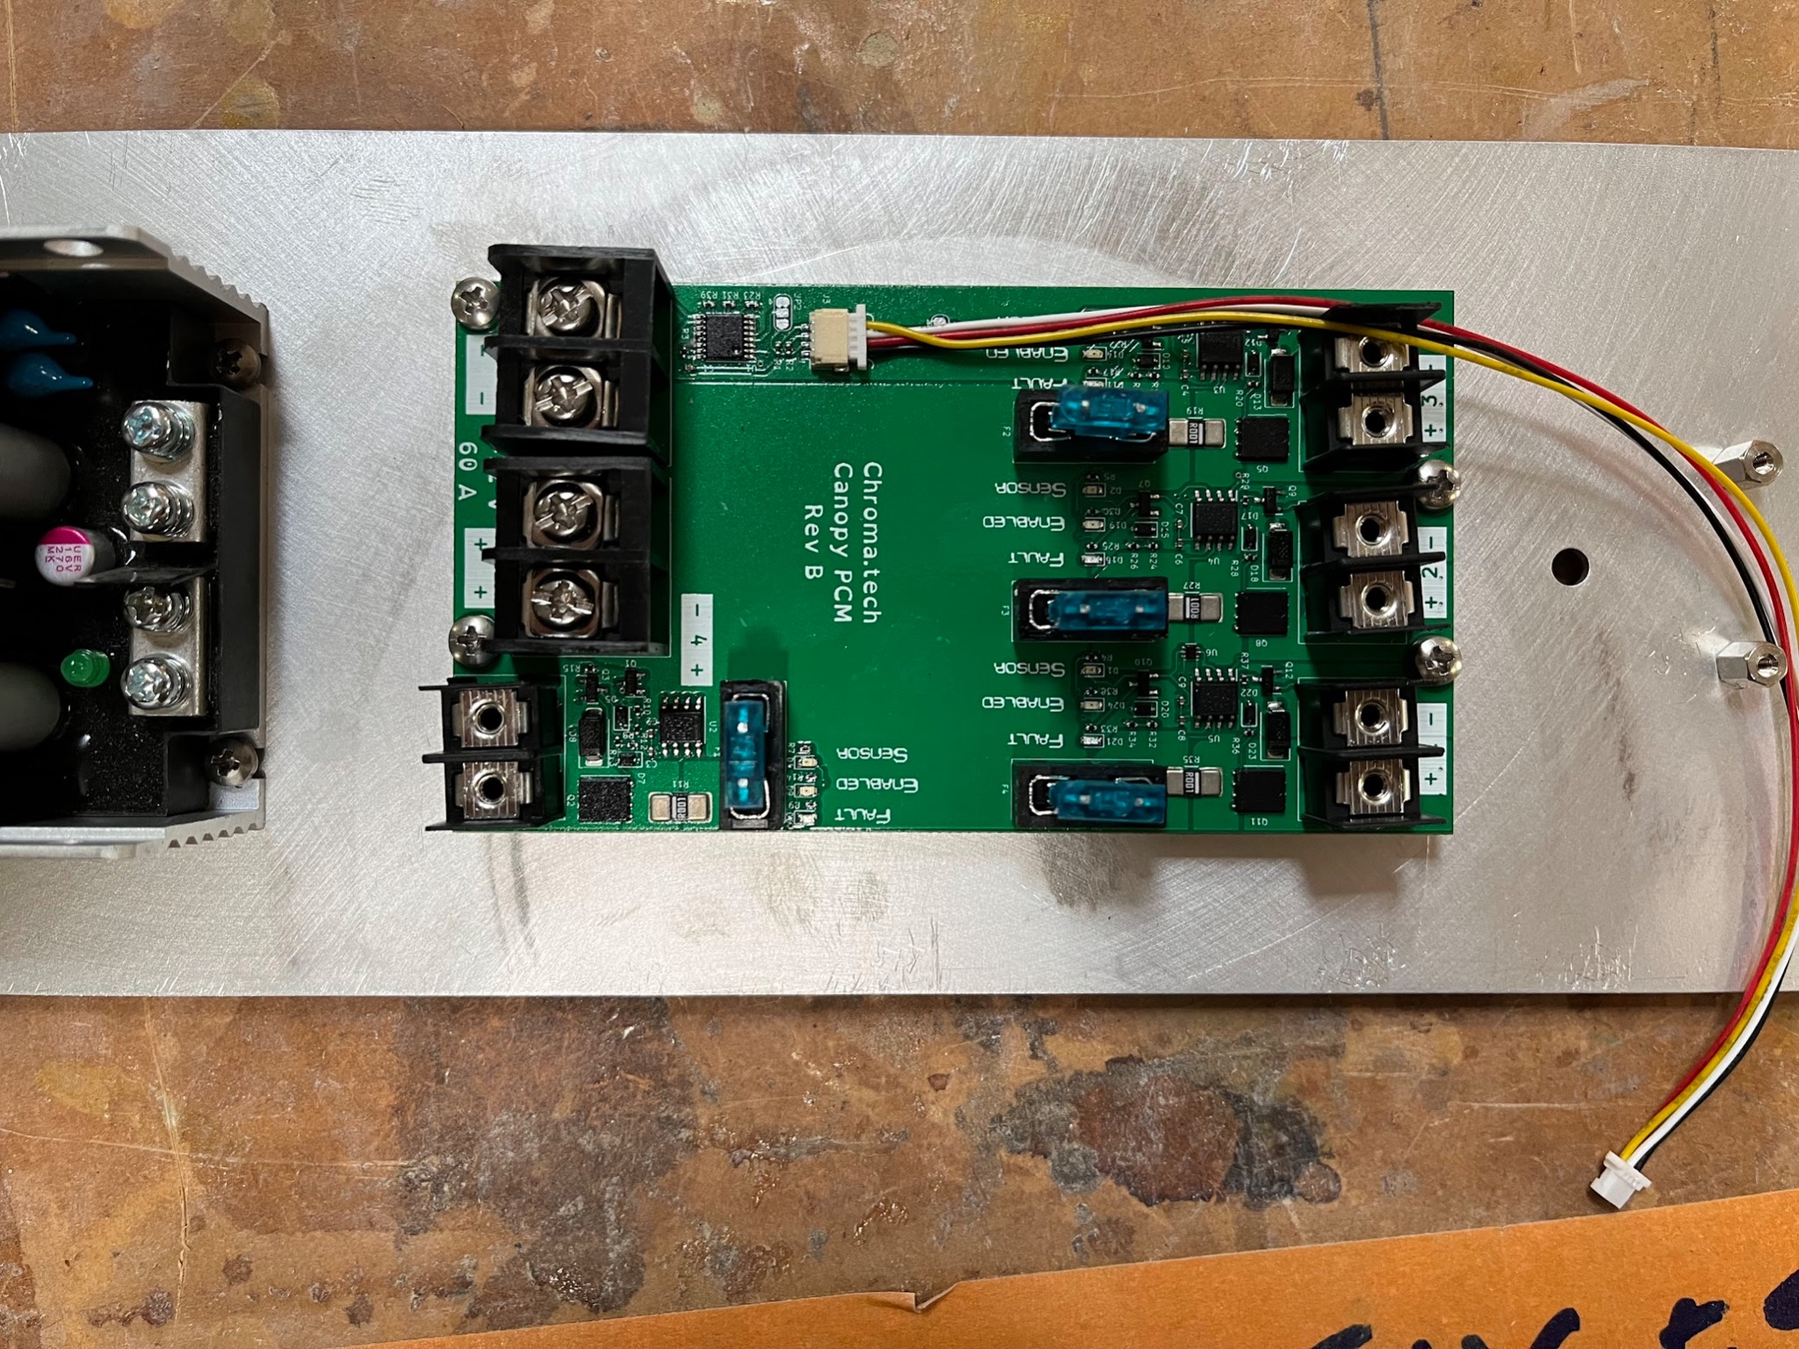

STATION 5: ADD ANGIO

1. Set a Bottom Plate Assembly at station
2. (Quality Control Station 4): Confirm All Screws in Canopy Board are tightened firmly
3. Set an Angio on top of its Standoffs in Orientation Pictured Below
4. Put a screw on the end of your screwdriver (the driver will hold the screw a bit)
5. Guide the screw into the standoff and start threading it but do not tighten all the way
6. Insert the remaining screws in each of the remaining 3 positions and tighten all 4 firmly.

ANGIO ORIENTATION NEXT TO ITS STANDOFFS

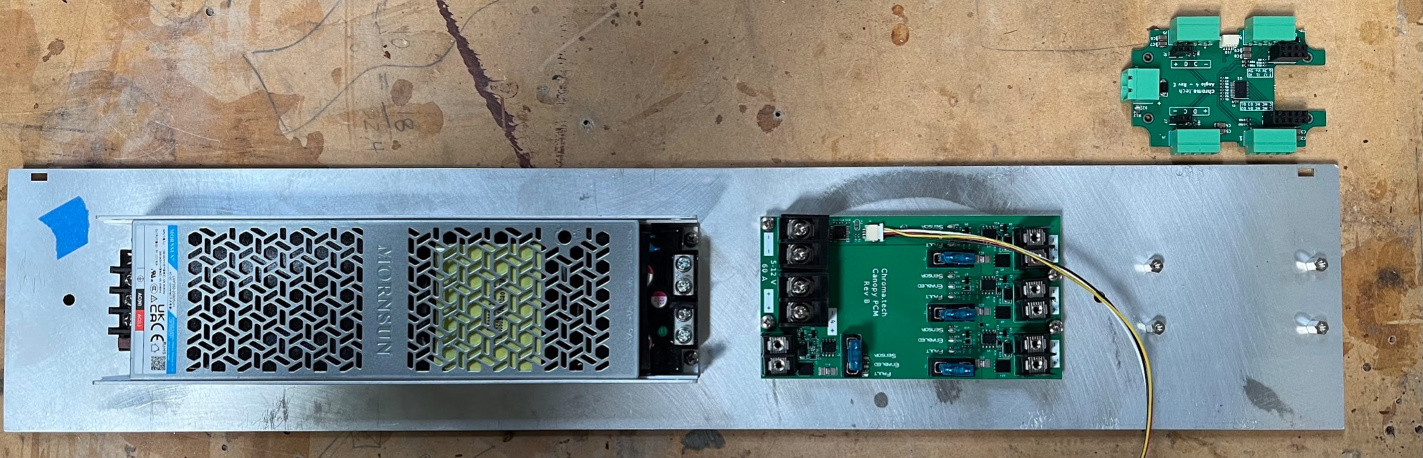

STATION 6: ADD Angio Ethernet Board

You need Instruction from a project lead to do this step

**Very Carefully** connect Ethernet Board to Angio

Visually confirm all Pins are Lined up and inserted properly

Connect Canopy Data Wire to Angio Port

Add Zip Tie next to the Data Wire on the Angio (it holds the two boards together so they won’t vibrate apart

Do a check - angio in place (screws are tightened, top and bottom properly connected, ziptie attached), canopy in place (screws are tightened), Mornsun in place (screws are tightened), data wire between canopy and angio properly connected.

**STATION 7: ADD Back Plate to AC**

1. QA Standoffs
   1. Check standoff screws from previous station are tight
2. QA Backplate
   1. All screws holding Neutrik to Back Plate are tight
   2. Check wire terminals are fully connected
   3. Check wire order on backplate
3. QA plate wires
   1. Check that back plate wires match diagram
4. Screw in wires
   1. Check that wires match diagram below
   2. DO NOT overtighten screw

Notes:

* Do not leave screws on table, always keep in bin. Put tools back when done.
* Black and white wire colors do not match “normal” conventions of live/neutral, but are consistent for all powerbox builds.

